## Ideation: Gemini Landmark Explorer

Project Phase: Project Design & Planning (Main Folder 02)

Sub Folder: Ideation

Date: June 20, 2025

**Team:**  
Kamlesh Chowdhary ( [kamlesh.23bce10260@vitbhopal.ac.in](mailto:kamlesh.23bce10260@vitbhopal.ac.in) )

Somil Asati ( [somil.23bce10364@vitbhopal.ac.in](mailto:somil.23bce10364@vitbhopal.ac.in) )

Devansh Tyagi ( [devansh.23bce10247@vitbhopal.ac.in](mailto:devansh.23bce10247@vitbhopal.ac.in) )

Prashasti Joshi ( [prashasti.23bce10893@vitbhopal.ac.in](mailto:prashasti.23bce10893@vitbhopal.ac.in) )

### 1. Problem Definition (Recap)

Travelers, educators, and cultural enthusiasts frequently encounter a challenge in obtaining immediate, rich, and contextual information about landmarks they observe or study [Source: Gemini_Landmark_Description_App_Final_Documentation.docx, Project Report Landmark Explorer.docx]. Existing solutions, such as traditional guidebooks or generic search engines, often fall short by being cumbersome, time-consuming, or lacking the depth and tailored narratives necessary to truly enhance understanding and appreciation of these significant sites [Source: Gemini_Landmark_Description_App_Final_Documentation.docx]. The core problem is the gap between visual discovery and instant, intelligent informational access.

### 2. Core Idea & Vision

The vision for the Gemini Landmark Explorer is to create an intuitive, AI-powered multimodal web application that provides instant, comprehensive, and scenario-based descriptions of iconic landmarks directly from user-uploaded images [Source: Gemini_Landmark_Description_App_Final_Documentation.docx, Project Report Landmark Explorer.docx]. Leveraging the advanced capabilities of Google's Gemini Pro Vision model, the app aims to transform passive viewing into an immersive learning experience by generating dynamic, human-like narratives and detailed insights about the history, significance, and architectural features of landmarks. This project exemplifies the real-world application of generative AI in enriching travel and cultural discovery.

### 3. Brainstorming: Key Features & Enhancements (Detailed Concepts)

Building upon the project's foundational goals, here are the key features and their conceptual details:

* **Core Description Generation:**
  + **Image Upload & Processing:** The application allows users to upload standard image formats like JPEG or PNG [Source: Gemini_Landmark_Description_App_Final_Documentation.docx]. Internally, the input_image_setup function processes the uploaded file by extracting its byte data and MIME type, preparing it for the AI model. A get_image_base64 function is used to render the uploaded image visually within the Streamlit interface.
  + **AI-Powered Multimodal Analysis:** The core of the app integrates with Google's generative AI, specifically leveraging the gemini-2.0-flash-001 model (as configured in app.py) which is well-suited for multimodal (image + text) input. The get_gemini_response function orchestrates this by sending both the image data and a dynamic text prompt to the model.
  + **Rich, Detailed Descriptions:** The AI is specifically prompted to generate comprehensive descriptions that include the landmark's name, precise location, historical background, cultural significance, and distinctive architectural features [Source: Gemini_Landmark_Description_App_Final_Documentation.docx].
  + **Optional Text Prompt:** Users can provide an additional text prompt or specific questions (e.g., "Tell me more about its construction," or "Who designed it?") via an st.text_input field to further guide the AI's response and tailor the information to their specific curiosity.
* **Scenario-Based Customization:**
  + **User Role-Driven Output:** The application implements selectable scenarios, including "Discovering Iconic Landmarks (Traveler)," "Tour Guide Assistance," "Virtual Tours and Educational Resources," and "Personal Exploration and Curiosity" [Source: Project Report Landmark Explorer.docx].
  + **Dynamic Prompt Engineering:** A dictionary of scenario_prompts within app.py ensures that the generative AI receives a tailored instruction set based on the selected scenario. This allows the same uploaded image to yield different narrative focuses and levels of detail, making the app versatile for various user needs. For instance, a "Tour Guide" prompt might emphasize anecdotes, while an "Educational Resource" prompt might focus on historical context and facts.
* **Accessibility & User Experience:**
  + **Intuitive Streamlit UI:** The application is built using Streamlit, providing a clean, responsive, and user-friendly web interface. Visual elements like st.title, st.markdown for clear headers, st.file_uploader with helpful placeholder text, and st.button for interaction enhance usability [Source: Gemini_Landmark_Description_App_Final_Documentation.docx].
  + **Multilingual Support:** A crucial feature for global accessibility, the app supports translation of the AI-generated descriptions into multiple languages, specifically English, Hindi, Spanish, French, and Japanese, utilizing the googletrans library via the translate_text function [Source: app.py, Project Report Landmark Explorer.docx].
  + **Downloadable Output:** Users have the option to download the generated and translated description as a text file (.txt) using an st.download_button, ensuring they can retain and share the information [Source: app.py, Project Report Landmark Explorer.docx].
  + **Session History:** The application maintains a session-based history of generated descriptions using st.session_state.history, allowing users to easily revisit previous analyses within their current session [Source: app.py, Project Report Landmark Explorer.docx].
  + **Feedback & Loading Indicators:** User experience is enhanced with visual feedback, including st.spinner during AI analysis and st.success upon completion of the description generation, improving perceived performance.
* **Underlying Infrastructure & Security:**
  + **Secure API Key Management:** The Google API Key necessary for accessing the Gemini model is securely loaded from a .env file using python-dotenv, preventing its exposure in the codebase [Source: Gemini_Landmark_Description_App_Final_Documentation.docx, app.py].
  + **In-Memory Image Processing:** For user privacy and data security, uploaded images are processed in memory and are explicitly *not* persistently stored by the application [Source: Gemini_Landmark_Description_App_Final_Documentation.docx, Project Report Landmark Explorer.docx].

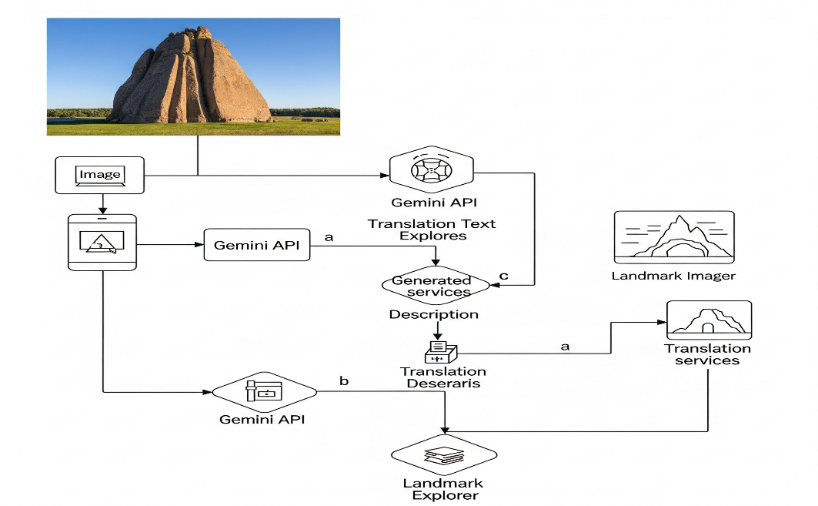

### 3.1 Visual Summary: Ideation Overview Flowchart

The following flowchart presents a visual snapshot of the ideation behind Gemini Landmark Explorer. It concisely illustrates the core problem, envisioned solution, major functional features, supported user roles, and out-of-scope boundaries for this project phase.

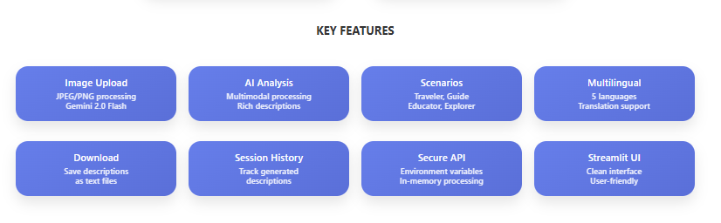

### 4. Target Audience

The Gemini Landmark Explorer is designed for a diverse range of users, each benefiting from its tailored capabilities:

* **Individual Travelers & Tourists:** Who desire immediate, on-the-spot information about landmarks encountered during their journeys, enhancing their sightseeing experience [Source: Gemini_Landmark_Description_App_Final_Documentation.docx].
* **History & Architecture Enthusiasts:** Individuals with a passion for cultural heritage can deepen their understanding and satisfy curiosity about global landmarks from home or while planning trips [Source: Gemini_Landmark_Description_App_Final_Documentation.docx, Project Report Landmark Explorer.docx].
* **Professional Tour Guides:** Seeking to enrich their narratives and provide engaging commentary by quickly accessing additional facts and anecdotes, complementing their existing expertise with AI-generated content [Source: Project Report Landmark Explorer.docx].
* **Educators & Students:** For developing immersive virtual tours, creating informative educational materials, and bringing historical sites to life in remote learning environments [Source: Project Report Landmark Explorer.docx].
* 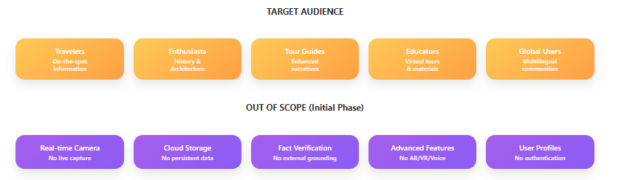**Multilingual Communities:** The translation feature specifically caters to diverse language speakers, ensuring broad accessibility to rich cultural information [Source: Project Report Landmark Explorer.docx].

### 5. Non-Goals / Out of Scope (for this initial phase)

To maintain focus and deliver a robust core product, the following functionalities are intentionally outside the scope of this initial project phase [Source: Gemini_Landmark_Description_App_Final_Documentation.docx, Project Report Landmark Explorer.docx]:

* **Real-time Camera Capture:** The application does not include direct integration with a device's camera for live image capture. Users are expected to upload pre-existing images.
* **Persistent Cloud Storage:** There will be no cloud storage of user profiles, uploaded images, or generated landmark information. All processing is transient and in-memory.
* **External Factual Grounding/Verification:** While the Gemini model is powerful, the app does not incorporate explicit external knowledge bases or verification mechanisms to "ground" or fact-check the AI's output against a definitive external source. The quality of output relies on the model's inherent knowledge and the provided prompts.
* **Advanced Multimodal Features:** Features such as voice output for descriptions (text-to-speech) or augmented/virtual reality (AR/VR) integrations are not included in this iteration.
* **User Authentication & Profiles:** There will be no user login, profile management, or personalized content history beyond the current session.

